A TECHNICAL REPORT ON STUDENTS INDUSTRIAL WORK EXPERIENCE SCHEME (SIWES)

HELD AT
ADAMA BEVERAGES LIMITED,
YOLA, ADAMAWA STATE

COVER PAGE

FROM: OCTOBER, 2024
TO: JANUARY, 2025

BY
SAAD USMAN BODEJO
(ST/CS/ND/23/193)

A SIWES REPORT SUBMITED TO THE DEPARTMENT OF COMPUTER SCIENCE, SCHOOL OF SCIENCE AND TECHNOLOGY FEDERAL POLYTECHNIC, MUBI, ADAMAWA STATE, NIGERIA

FEBRUARY, 2025

A TECHNICAL REPORT ON STUDENTS INDUSTRIAL WORK EXPERIENCE SCHEME (SIWES)

HELD AT
ADAMA BEVERAGES LIMITED,
YOLA, ADAMAWA STATE

TITLE PAGE

FROM: OCTOBER, 2024
TO: JANUARY, 2025

BY
SAAD USMAN BODEJO
(ST/CS/ND/23/193)

A SIWES REPORT SUBMITED TO THE DEPARTMENT OF COMPUTER SCIENCE, SCHOOL OF SCIENCE AND TECHNOLOGY FEDERAL POLYTECHNIC, MUBI, ADAMAWA STATE, NIGERIA
IN PARTIAL FUFILMENT OF THE REQUIREMENTS FOR THE AWARD OF NATIONAL DIPLOMA (ND) IN COMPUTER SCIENCE

FEBRUARY, 2025

ATTESTATION
I Saad Usman Bodejo hereby attest that I did my Industrial Attachment Program at Adama Beverages Limited, Yola Adamawa State between October, 2024, to January, 2025, and this report is prepared by me and submitted to the SIWES coordinator as required. I understand that all the information contained in this report are correct and will be penalized if found to be false. I also know that the SIWES coordinator may request for additional evidence as requested for reconciliation.

………………………………………… ………………………………..
Saad Usman Bodejo DATE
(ST/CS/ND/23/193)

CERTIFICATION
This is to certify that Saad Usman Bodejo with a registration number ST/CS/ND/23/193 undergoes his industrial training SIWES at Adama Beverages Limited, Yola, Adamawa State. In partial fulfillment of the requirements for the award of National Diploma (ND) in computer science, Federal Polytechnic, Mubi, as certified by the undersign officer.

Mr. Hyellamada Simon …………………………
DEPARTMENTAL SIWES CO-ORDINATOR DATE

DEDICATION
I offer this work to my cherished family and friends, including the Alh. USMAN BODEJO’S family and my companions in our shared journey as studies persist. With love and sincere wishes, may the Almighty bless our achievements.

ACKNOWLEDGMENTS
I express gratitude to Almighty Allah for granting me life, health, wisdom, and the capability to fulfill this endeavour.
I whole heartedly thank my Head of department Mallam Kassim Mustapha, SIWES coordinator Mr. Hyellamada Simon and all lectures of Computer Science for their effort to ensure my success as their students.
My gratitude goes to my parent for their prayers, financial and moral support during my attachment. I also appreciate the kind gesture of my brothers and sisters and those who supports me in prayers and contribution during my industrial attachment.
I extend my deep appreciation to the entire management and staff of Adama Beverages Limited Yola for their prompt and invaluable support, ensuring our success in our educational endeavors. Special thanks go to my supervisors, Mr. Umar Usman Suleiman and Mr. Babangida Adamu Aliyu, for there tireless oversight of my activities and there guidance in rectifying any mistakes that may arise.
I am greatly indebted to my co-SIWES students to mention, may God strengthen our relationship together and grant us academic excellence.
I sincerely thank you all for your contribution and support.

TABLE OF CONTENTS
COVER PAGE i
TITLE PAGE i
ATTESTATION ii
CERTIFICATION iii
DEDICATION iv
ACKNOWLEDGMENTS v
1.1 BRIEF HISTORY OF SIWES 1
1.2 AIMS AND OBJECTIVES OF SIWES 2
1.3 ROLES OF STUDENT 2
1.4 OBJECTIVES OF THE REPORT 2
CHAPTER TWO: HISTORY OF THE ORGANIZATION 3
2.1 ORGANIZATIONAL STRUCTURE 3
2.2 BRIEF HISTORY OF ADAMA BEVERAGES LTD (FARO) ABL 4
CHAPTER THREE: WORK EXPERIENCE I 5
3.1 INTRODUCTION TO NETWORKING 5
3.1.1 NETWORK 5
3.1.2 NETWORK CATEGORIES 6
3.1.3 MAC ADDRESS 13
23-45-67-89-AB or 01:23:45:67:89: AB 13
CHAPTER FOUR: SUMMARY, CONCLUSION AND RECOMMENDATIONS 17
4.1 Summary 17
4.2 Conclusion 17
4.3 Recommendations 17
REFERENCES 18

CHAPTER ONE: INTRODUCTION

1.1 BRIEF HISTORY OF SIWES
SIWES was founded in 1973 by ITF (Industrial Training Funds) to address the problem of tertiary institution graduates' lack of appropriate skills for employment in Nigerian industries. The Students' Industrial Work Experience Scheme (SIWES) was founded to be a skill training programme to help expose and prepare students of universities, Polytechnics and colleges of education for the industrial work situation to be met after graduation.
This system facilitates the transfer from the classroom to the workplace and aids in the application of knowledge. The program allows students to become acquainted with and exposed to the experience required in handling and operating equipment and machinery that are typically not available at their schools.
Prior to the establishment of this scheme, there was a rising concern and trend among industrialists that graduates from higher education institutions lacked appropriate practical experience for employment. Students who entered Nigerian universities to study science and technology were not previously trained in the practical aspects of their chosen fields. As a result of their lack of work experience, they had difficulty finding work.
As a result, employers believed that theoretical education in higher education was unresponsive to the needs of labor employers. Thousands of Nigerians faced this difficulty till 1973. The fund's main motivation for establishing and designing the scheme in 1973/74 was launched against this context.
The ITF (Industrial Training Fund) organization decided to aid all interested Nigerian students and created the SIWES program. The federal government officially approved and presented it in 1974. During its early years, the scheme was entirely supported by the ITF, but as the financial commitment became too much for the fund, it withdrew in 1978. The National Universities Commission (NUC) and the National Board for Technical Education (NBTE) were given control of the scheme by the federal government in 1979. The federal government handed over supervision and implementation of the scheme to ITF in November 1984. It was taken over by the Industrial Training Fund (ITF) in July 1985, with the federal government bearing entire responsibility for funding.

1.2 AIMS AND OBJECTIVES OF SIWES
The Industrial Training Fund’s Policy Document No. 1 of 1973 which established SIWES outlined the objectives of the scheme as:
- Provide an avenue for students in Institutions of higher learning to acquire industrial skills and experience in their respective courses of study.
- Prepare students for the Industrial Work situation they are likely to experience after graduation.
- Expose students to work methods and techniques of handling equipment and machinery that may not be available in their Institutions.
- Make the transition from school to the world of work easier; and enhance students’ networks for later job placements.
- Provide students with an opportunity to apply their knowledge to real work situations, thereby bridging the gap between theory and practice; and vi. Enlist and strengthen Employers’ involvement in the entire educational process; thereby preparing the students for employment in Industry and Commerce.

1.3 ROLES OF STUDENT
- Attend SIWES orientation programme before going on attachment.
- Comply with the establishment’s rule and regulation.
- Arrange living accommodation during the period of attachment.
- Record all training activity done and other assignment in the log book.
- Complete SPEI from ITF, FORM 8 and get it endorsed by the employer for submission to the ITF.

1.4 OBJECTIVES OF THE REPORT
The objectives of the SIWES report are;
- To make thorough explanation of the work done during my four-month industrial training.
- To fulfill the requirement for national diploma in computer science.
- To contribute to the body of knowledge and to enhance the understanding of the writer about a similar or same job.

CHAPTER TWO: HISTORY OF THE ORGANIZATION

2.1 ORGANIZATIONAL STRUCTURE

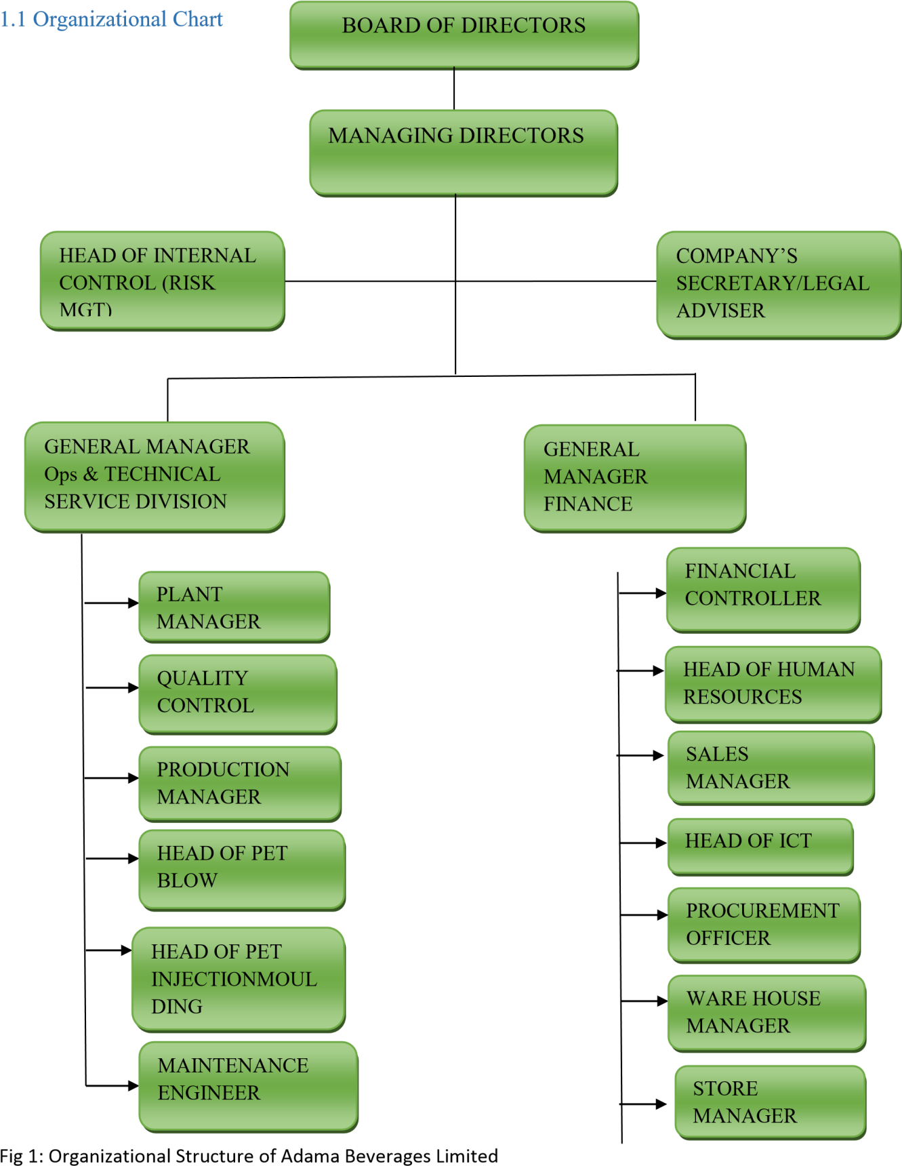
Figure 2.1: Organizational Chart

2.2 BRIEF HISTORY OF ADAMA BEVERAGES LTD (FARO) ABL
Adama Beverages Limited (ABL) is a wholly owned Nigerian company that is duly registered with the Corporate Affairs Commission (CAC) as Limited Liability Company. The company was incorporated on 2nd January, 2004 in accordance and compliance with the provisions of the Companies and Allied Matter Act 1990 of the Federal Republic of Nigeria. The registration No. is 501520. The company at inception aimed at providing finest quality processed Table water, Natural juice and fruit drinks to each Nigerian and the neighboring countries. It however, started with the production of high quality sachet water pouches for the local community and started commercial production of table water from January 2007 while the production of Natural fruit juice commenced in June 2008.
Adama Beverages Limited also known as FARO has several lines dedicated to the production of table water, fruit juices, sachet and 20Litres jar refilling. The company is self-dependent in all its basic requirements and production processes viz production of PET performs, blowing of bottles of all sizes, production of HDPE caps etc. Adama Beverages Limited in its aim to be a leading and reputable food and Beverages organization has continuously been increasing its customer base from the northern part of Nigeria to the south and western part of Nigeria. Presently the company has over 200 valuables distributors in 26 states of the country. The company is located at Kofare Industrial layout around Numan road, Jimeta–Yola Adamawa State Nigeria. The company has a work force of over 400 staffs which includes expatriates, other professionals and non-professionals.
Mission Statement
To be a conglomerate that create employment opportunities under favorable working conditions while aspiring to contribute to the human, social and economic development of our country and be environmentally conscious friendly.
Vision Statement
To be a leader in the foods and beverages industries that satisfies the desires of consumer through the provision of world class quality products and service delivery.

CHAPTER THREE: WORK EXPERIENCE I

3.1 INTRODUCTION TO NETWORKING
I commenced my IT placement at Adama Beverages Limited on October 7th, 2024. Upon arrival, I introduced myself to the Group Head of Human Resources and received a warm welcome. Subsequently, I was acquainted with other staff members working in the ICT Unit of the company. Along with fellow IT students, we underwent orientation sessions outlining the objectives and expectations for our IT period. Topics covered included the significance of the IT program, the regulations of Adama Beverages Limited, procedures for attendance tracking, maintaining a logbook, effective communication with staff, students, and visitors, as well as the process for seeking assistance from management. Additionally, supervisors were assigned to oversee our progress and endorse our logbooks on a weekly basis. Furthermore, specific departmental assignments were made, and I was designated to the ICT Unit.
Responsibilities of the department include:
  - Troubleshooting server
  - Tally troubleshooting.
  - Networking maintenance (restart radio, reboot modem, creeping cables e.t.c)
  - Winbox maintenance.

3.1.1 NETWORK
A network refers to two or more connected computers that can share resources such as data, a printer, an Internet connection, applications, or a combination of these resources. A network is any collection of independent computers that communicate with one another over a shared network medium. Every network includes:
- At least two computers Server or Client workstation.
- Networking Interface Card's (NIC)
- A connection medium, usually a wire or cable, although wireless communication between networked computers and peripherals is also possible.
- Network Operating system software, such as Microsoft Windows NT or 2000, Novell NetWare, Unix and Linux.

Types of Network
- Local Area Network (LAN)
- Metropolitan Area Network (MAN)
- Wide Area Network (WAN)

Local Area Network: LAN are network usually confined to a geographic area, such as a single building or a college campus. LANs can be small, linking as few as three computers, but often link hundreds of computers used by thousands of People. The development of standard networking protocols and media has resulted in worldwide proliferation of LANs Throughout business and educational organizations.
Metropolitan Area Network: MAN covers a large area than that of a LAN and smaller area as compared to WAN. It connects two or more computers that are apart but resides in the same or different cities.
Wide Area Network: WAN combines multiple LANs that are geographically separate. This is accomplished by connecting the different LANs using services such as dedicated leased phone lines, dial-up phone lines (both synchronous and asynchronous), satellite links, and data packet carrier services. Wide area networking can be as simple as a modem and remote access server for employees to dial into, or it can be as complex as hundreds of branch offices globally linked using special routing protocols and filters to minimize the expense of sending data sent over vast distances.

3.1.2 NETWORK CATEGORIES
Network can be divided in to two main categories:
1: Peer-to-peer: In peer-to-peer networking there are no dedicated servers or hierarchy among the computers. All of the computers are equal and therefore known as peers. Normally each computer serves as Client/Server and there is no one assigned to be an administrator responsible for the entire network.
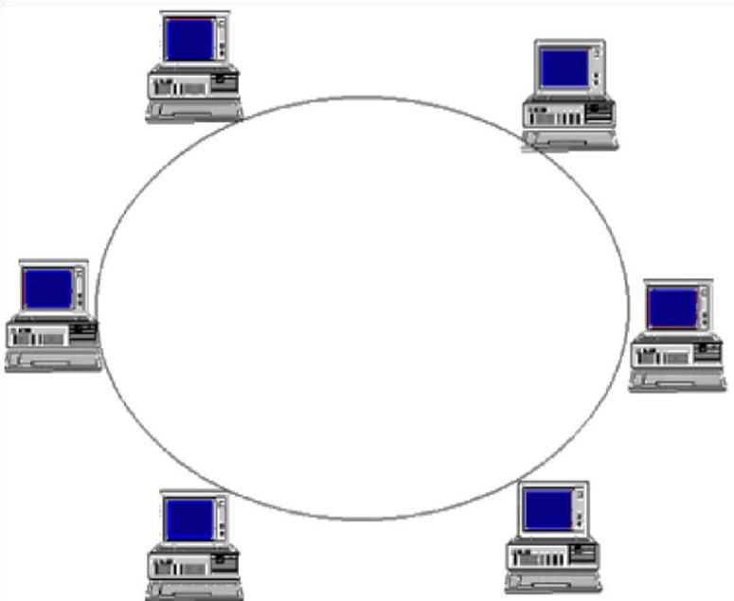
Figure 2: Peer to peer connection
2: Client/server application design also lets the application provider mask the actual location of application function. The user often does not know where a specific operation is executing. The entire function may execute in either the PC or server, or the function may be split between them.
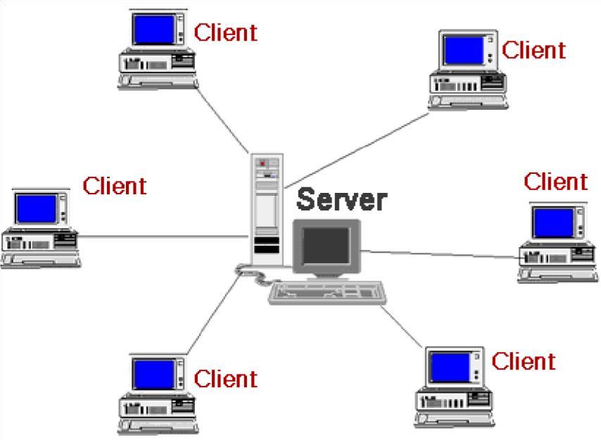
Figure 3: Client/server connection

Network Devices
Hub: A hub is basically a multiport repeater. A hub connects multiple wires coming from different branches, for example, the connector in star topology which connects different stations. Hubs cannot filter data, so data packets are sent to all connected devices.
Switch: A switch is a multiport bridge with a buffer and a design that can boost its efficiency (a large number of ports imply less traffic) and performance. A switch is a data link layer device. The switch can perform error checking before forwarding data that makes it very efficient as it does not forward packets that have errors and forward good packets selectively to correct port only.
Routers: A router is a device like a switch that routes data packets based on their IP addresses. Router is mainly a Network Layer device. Routers normally connect LANs and WANs together and have a dynamically updating routing table based on which they make decisions on routing the data packets. Router divide broadcast domains of hosts connected through it.
A bridge: operates at data link layer. A bridge is a repeater, with add on the functionality of filtering content by reading the MAC addresses of source and destination. It is also used for interconnecting two LANs working on the same protocol. It has a single input and single output port, thus making it a 2-port device.

Firewalls
A firewall is a networking device that is installed at the entrance to a LAN when connecting networks together, particularly when connecting a private network to a public network, such as the internet. The firewall uses rules to filter traffic into and out of the private network, to protect the private network users and data from malevolent hackers.
Firewalls are either hardware or software, depending on their intended use. A firewall used to protect a network is a hardware device that should be installed in the network between the router and the network.

Network Interface Card (NIC)
A NIC (pronounced 'nick') is also known as a network card. It connects the Computer to the cabling, which in turn links all of the computers on the network together. Each computer on a network must have a network card.

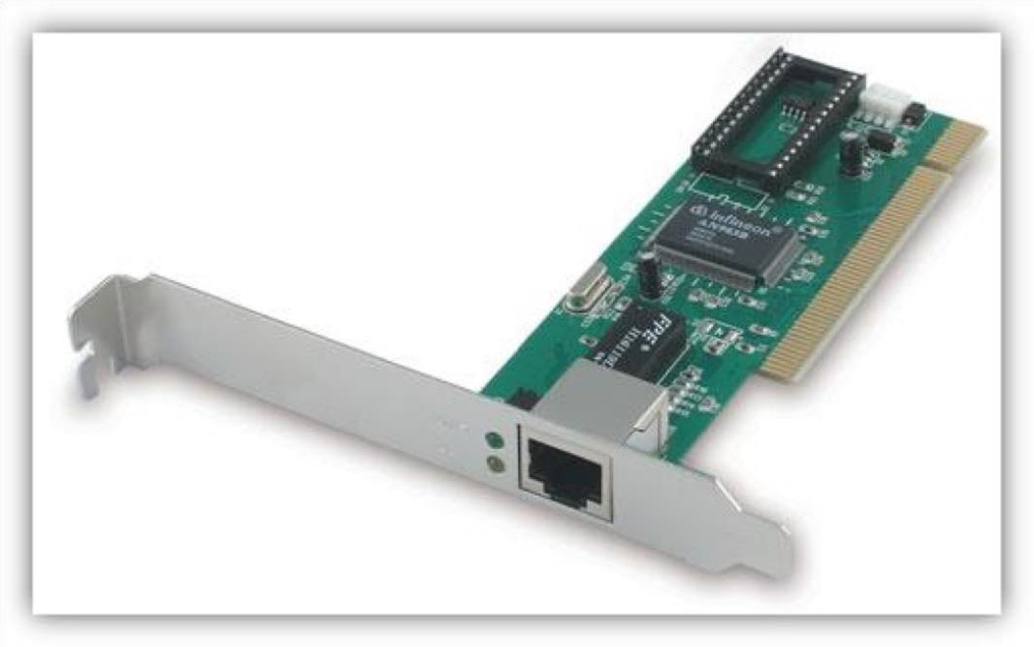
Figure 4: Network Interface Card (NIC)

Open System Interconnected Model
The Open System Interconnection model is a seven-layer structure that specifies the requirements for communications between two computers. The ISO (International Organization for
Standardization) standard 7498-1 defined this model. This model allows all network elements to operate together, no matter who created the protocols and what computer vendor supports them.
The main benefits of the OSI model include the following:
- Helps users understand the big picture of networking
- Helps users understand how hardware and software elements function together
- Makes troubleshooting easier by separating networks into manageable pieces
- Defines terms that networking professionals can use to compare basic functional relationships on different Networks.

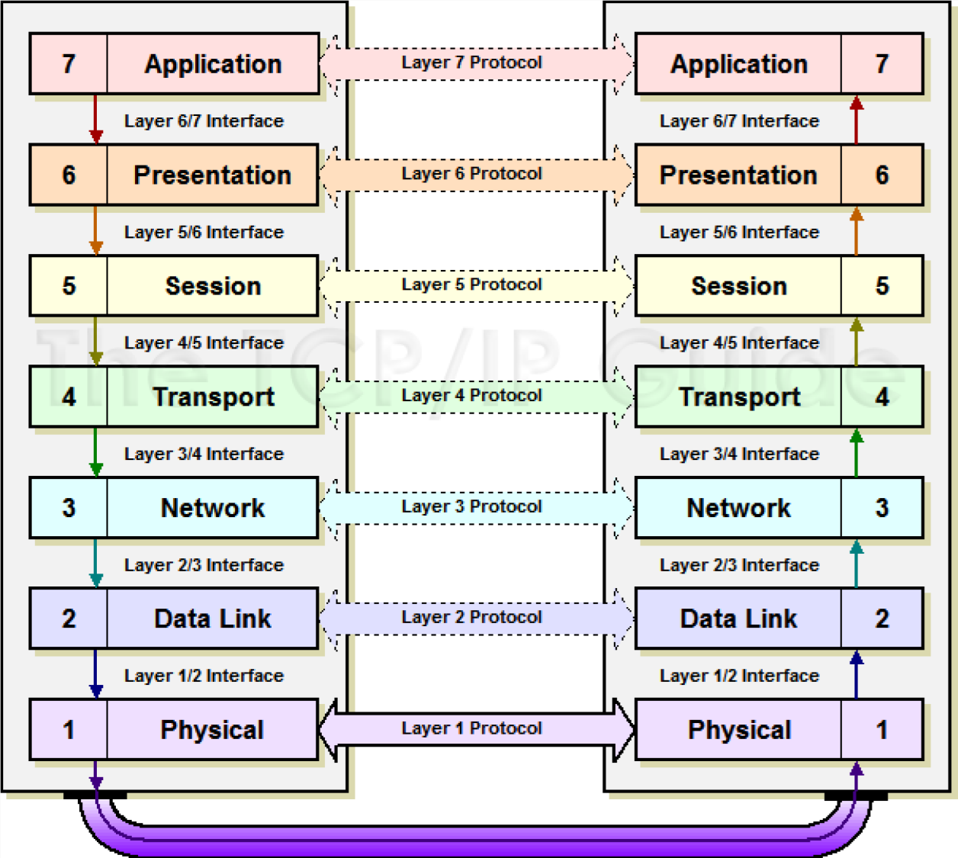

Figure 5: OSI MODEL

Application Layer: This layer is responsible for providing interface to the application user. This layer encompasses protocols which directly interact with the user.
Presentation Layer: This layer defines how data in the native format of remote host should be presented in the native format of host.
Session Layer: This layer maintains sessions between remote hosts. For example, once user/password authentication is done, the remote host maintains this session for a while and does not ask for authentication again in that time span.
Transport Layer: This layer is responsible for end-to-end delivery between hosts.
Network Layer: This layer is responsible for address assignment and uniquely addressing hosts in a network.
Data Link Layer: This layer is responsible for reading and writing data from and onto the line.
Link errors are detected at this layer.
Physical Layer: This layer defines the hardware, cabling, wiring, power output, pulse rate etc.
IP Address and Subnet Mask an IP (internet protocol) address is a numeric description. Each device that is connected to a computer network based on internet technology is allocated an ip address. This IP address uses the internet protocol for communication. Example 192.168.0.1

Version of IP
IPV4 (INTERNET PROTOCOL VERSION 4) used 32-bit ip address. So the maximum number of address is 2³²—or 4,294,967,296. This is a little more than four billion ip address. An ipv4 address is typically formatted as four 8-bit field. Each 8-bit field represents a byte of the ipv4 address. Example of ipv4 192.168.0.1
IPV6 (INTERNET PROTOCOL VERSION 6) was developed by internet engineering task force (IETF). Ipv6 intended to replace of ipv4. Ipv6 uses a 128-bit address and it allows 2128 i.e. approximately 3.4x1038 address. The actual number is slightly smaller as some ranges are reserved for special use or not used. The ipv6 address is represented by 8 groups for four hexadecimal digit with the group being supported by colon. Example of ipv6
2001:0db8:0042:0000:8a2e:0370:7334:0000
The byte of the ipv4 is further classified into two (2) parts.
- The network part: network part this part specifies the unique number assigned to your network. It is also identifies the class of network assigned. The network part takes two bytes of the ipv4 address. 192.168.0.1 is an example of ipv4 while 192.168 is represented as network part.
- The host part: host part this is the part of the ipv4 address that you can assign to each host. It uniquely identifies this machine on the network. For all host on your network, the network part of the ip address will be the same and host part will be changing

Table 1: Classes of IP Address
S/N | NAME OF CLASS | STARTING FROM | TO
1 | Class A | 1.0.0.0 | 127.0.0.0
2 | Class B | 128.0.0.0 | 192.0.0.0
3 | Class C | 192.0.0.0 | 233.0.0.0
4 | Class D | 234.0.0.0 | 255.0.0.0

Types of IP Address
- STATIC IP ADDRESS: usually never change but rather they may be change as a result of network administration. They serve as a permanent internet address and provide a simple and reliable way for the communication. From the static ip address of a system, we can get many details such as the continents, country, region and city in a computer located.
- DYNAMIC IP ADDRESS: are they second categories. These are temporary ip address.
These IP addresses are assigned to a computer when they get connected to the internet each time.
They are actually borrowed from a pool of ip addresses, shared over various computers.

Subnet Mask
Subnet mask is a 32-bit numbers that mask an IP address, and divided the IP address into network address and host address. Subnet mask is made by setting network bits to all “1”s and setting host bit to all “0”s. example 255.0.0.0, 255.255.0.0
Table 2: IP address and subnet mask
S/N | NAME OF CLASSES | IP ADDRESS | SUBNET MASK
1 | Class A | 1.0.0.0 to 127.0.0.0 | 255.0.0.0
2 | Class B | 128.0.0.0 to 191.0.0.0 | 255.255.0.0
3 | Class C | 192.0.0.0 to 233.0.0.0 | 255.255.255.0
4 | Class D | 234.0.0.0 to 254.0.0.0 | 255.255.255.255

3.1.3 MAC ADDRESS
A Media Access Control address (MAC address) is a unique code assigned to a device and used to identify it when you connect to a network or wireless hotspot.
A MAC Address is a static, or non-changing, code that is used to identify a device on the network.
The format is six groups of two digits each, usually separated by hyphens or colons, such as 01-

23-45-67-89-AB or 01:23:45:67:89: AB
NOTE: MAC Addresses only use the characters A-F or a-f and the numbers 0-9.

Configuration
Configuration is the manner in which components are arranged to make up the computer system. Configuration consists of both hardware and software components. In communication or computer system, a configuration of a system refers to the arrangement of each of its functional units, according to their nature, number and chief characteristics.
IP CONFIG (internet protocol configuration) is a console application of some operating system that display all current TCP/IP network configuration values and refresh dynamic host configuration protocol (DHCP) and domain name system (DNS).

Winbox
Winbox is a small utility they allows administrator of mikroTikrouter OS using a fast and simple GUI. It is a native win32 binary, but can be on Linux and macOs (OSX) using wine. All winbox interface functions are as close as possible mirroring the console function that is why there are no winbox sections in the manual. Some of advanced and system critical configurations are not possible from winbox, like MAC address change on an interface.
Winbox is the graphical configured application for routerOS. Download it, run it and connect to your router- all routerOS functionality can be controlled with this application.

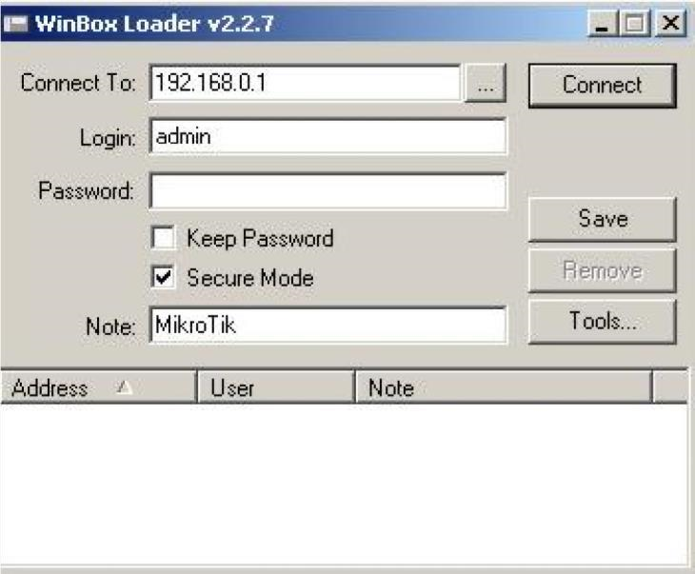
Figure 6: Winbox interface

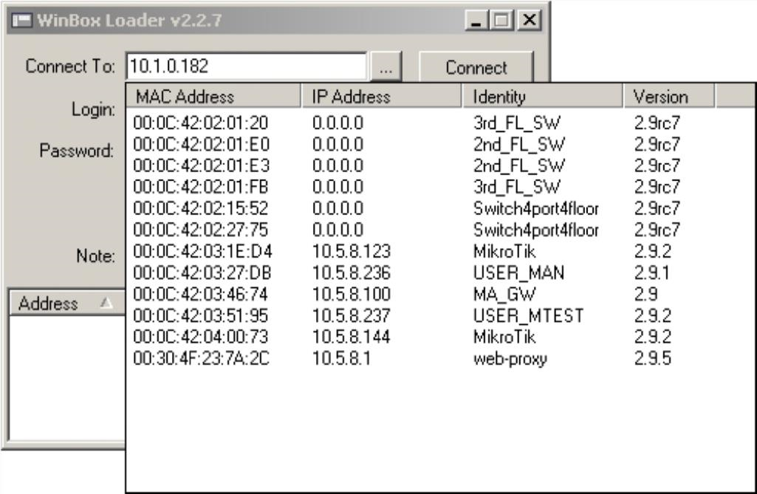
Figure 7: Winbox interface 2

Network Address Translation (NAT)
Is a method of mapping an IP address space into another by modifying network address information in the IP header of packets while they are in transits across a traffic routing device? The techniques were originally used to avoid the need to assign a new devices to every host when a network was moved, or when the upstream ISP was replaced, but could not route the networks address space. It became a popular and essential tool in conversing global address space in the face of IPv4 address exhaustion.
NAT allows a single device, such as a router, to act as an agent between the
Internet (or public network) and a local network (or private network), which means that only a single unique IP address is required to represent an entire group of computers to anything outside their network. Example if local IP address is 192.168.9.55 the NAT translates the IP address to 211.54.0.33 to the public network.

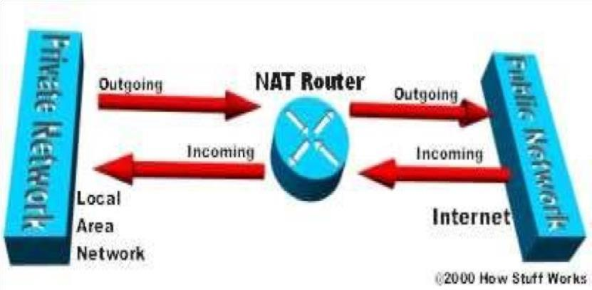
Figure 8: NAT router

Gateway
Gateway is a network connecting device that can be used to connect two devices in two different networks implementing different networking protocol and overall network architecture. In other word, a gateway is a node on a node on a network that serves as an entrance to another network. A gateway is a node (router) in a computer network, a key stopping point for data on its way to or from other networks. Thanks to gateways, we are able to communicate and send data back and forth. The Internet wouldn’t be any use to us without gateways (as well as a lot of other hardware and software).A gateway operates in all the layers of the OSI model, so it can be used as a onestop solution for all kinds of network devices connectivity’s.

Advantages of Gateway
- It can connect the device the device of two different network having dissimilar structures.
- It has the fastest data transmission speed amongst all network connecting devices.
- It has improved security than any other network connecting devices.

Disadvantages of Gateway
- It is complex to design and implement.
- The implementation cost is very high.
- It require a special system administration configuration.

Description of task
- Restarting mikrotik radio using a winbox software, rebooting modem, assigning local IP address to devices that are on different unit within the organization.
- Sharing of network resources among peripheral device such as printer and scanner that are on the same network (LAN).
- Crimping of Ethernet cable CAT 5/6 with an RJ 45 jack.

CHAPTER FOUR: SUMMARY, CONCLUSION AND RECOMMENDATIONS

4.1 Summary
During the course of the Industrial Training, I was able to have a practical exposure to the practical knowledge of many things that where though theoretically in networking and I was also exposed to the technical knowledge of the information technology, human relationship, working with a superior in a new environment. Professionally.

4.2 Conclusion
From the experience I gained with ABL under ICT unit, I can say I have gained much knowledge which is in consistent with my line of discipline (Information Technology. The practical experience I have gained has bridged my gap between the theory and the real-world applications. I am also grateful to ADAMA BEVERAGES LIMITED who has given me the opportunity to train with them and use their resources.
I am also indeed grateful to my supervisor who organized classes and tasks for us the IT students.
And lastly, I am grateful to Industrial Training Fund for sponsoring and supervising the SIWES IT.

4.3 Recommendations
From my experience during the IT, I would like to put forward these recommendations:
- The ITF should ensure that the backlog in payment of student’s allowances is cleared urgently to remove the negative image being created for SIWES.
- There should be strict supervision of students on industrial training, this will encourage them and help to determine their pace of learning while on SIWES program.
- Fellow IT students should be more dedicated to IT networking because this will help them enhance and acquire more practical knowledge or skills.
- Government should also create a system through ITF to be supporting organizations sponsoring IT students so that more students could be given chances and with more attention.

REFERENCES
Edward, B. (2003). The Effect of SIWES on a student, Federal Ministry of Works, Lagos. Nigeria.
John, Doe (2008). International Journal of Computer Science and Information Technology Research, 2(3), 461-466

